Boris Altshuler,
Theoretical Physics Department,
P.N. Lebedev Physics Institute of the Russian Academy of Sciences
31/05/2021 Report on the Quarks workshop - 2021 ”Integrability, Holography, Higher-Spin Gravity and Strings” dedicated to Sakharov’s 100 years, online,
May 31 — June 5, 2021.

The genius of a design engineer: bomb, universe, human society. To the Andrei Sakharov Centenary

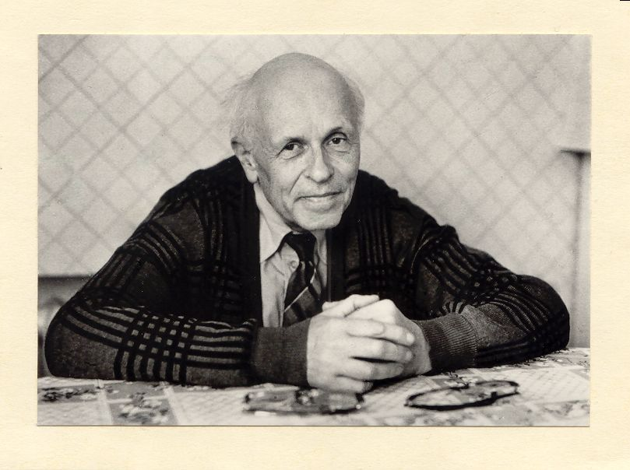
Andrei Dmitrievich Sakharov (21/05/2021 – 14/12/1989)

Andrei Sakharov died more than 30 years ago. Why is he important today? Here I’ll try to show that his public, moral and scientific legacy (the first two being intimately connected) are essentially relevant today.

Surely it is amazing by itself that the creator of the most terrible weapon in the history of mankind became the Nobel Peace Prize Winner. Sakharov's fate is, one might say, an exciting detective story, a chain of incredible events, not accidental however, but dictated by the genius and fortitude of the protagonist. His special role became even more visible after “Sakharov’s” KGB and Politburo documents were recently declassified. They show that Sakharov was considered an expert by all ever changing leaders of the USSR, from Lavrenti Beria to Mikhail Gorbachev. In 1948-1967 he was an expert on nuclear armament, but in 1968-1989 he became an expert on nuclear disarmament, on the international security, and on saving the mankind from the suicide of a thermonuclear war. His proposals were studied and some of them were even implemented by the Government.

Sakharov never belonged to any State power structures, he always remained an independent expert. “I'm not on the top floor. I'm next to the top floor - on the other side of the window”, - he joked ones. (I used these Sakharov’s words in the title of my book [1] published here in Moscow few days ago). Isn’t it an extremely dangerous position – on the enormous height on the other side of the window? This Sakharov’s joke accurately reflects the uniqueness and irrationality of his status, which has become his fate. This special status has not yet guaranteed the personal safety and safety of Sakhrov’s loved ones who became the hostages of his public activities. To tell truth, Sakharov was saved in extreme situations in exile only thanks to the support of Western colleagues. I personally also was not arrested thanks to this support. I take a chance to tell my gratitude to John Archibald Wheeler, Joel Lebowitz, David Finkelstein and many others. Thank you! We still do not fully understand the mechanisms of the influence of this support on the Soviet ruling elite, but we know that it worked. It looked like a miracle, but this was an observable fact confirmed by the repeated experiments.

Now in short about the very beginning of the first Sakharov’s wonder when simple young researcher, just PhD, became so important for Kremlin tops. It is well known that in 1945 some scientists - participants of the US Manhattan Project, being convinced in the necessity to restore nuclear balance of the former anti-Hitler coalition allies and with great risk for their lives, gave to Soviet intelligence secrets of the first US A-bomb and of the first ideas of “Super” – hydrogen bomb. This Super proved to be the dead-alley construction in the USA and in the USSR as well.

Thus in the beginning of 1948 there was a Decree of the Soviet Government on creation in a number of Moscow scientific institutions of the special groups aimed at development of the H-bomb. In the Theordep of the Lebedev Institute (FIAN) this group was headed by Igor Tamm. Andrei Sakharov, Vitaly Ginzburg and four other theoreticians were included in this group. Very quickly, in two months, Sakharov suggested the H-bomb construction quite different from Super. Here you see the model of the Sakharov-Ginsburg Sloika (from Russian “sloi” – “layer”).

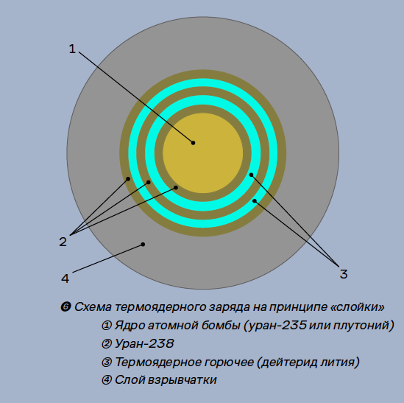

Vitaly Ginzburg proposed to use lithium-6 deuteride as a fusion fuel instead of heavy water, whereas Sakharov proposed to alternate layers of lithium-6 deuteride with layers of the heavy element uranium-238. The idea was untrivial. After the outer thick layer of the ordinary explosives is initiated and the shock wave makes the central A-bomb (U-235 or Plutonium) to explode the temperature of the intermediate layers reaches millions of degrees which by itself is still insufficient to ignite the thermonuclear reaction in lithium-6 deuteride. Sakharov guessed that because of the full ionization at the layers shown at the picture the lithium-6 deuteride will be additionally compressed by the factor of order 10, then thermonuclear ignition will follow. Why it will be additionally compressed? Because of the essential difference of the number of electrons of heavy and light elements of the layers; at full ionization at millions of degrees the equality of pressures of the electron gases in two neighboring layers of U-238 and of lithium-6 deuteride may be realized only if the density of lithium-6 deuteride will increase correspondingly.

Government approved this direction of work and since then Sakharov gradually becomes VIP nuclear scientist for the Kremlin. His post-graduate mate in the Lebedev Institute Matvei Rabinovich remembers (in “Facets of a Life” [2]):

“Once Andrei told me: “This sort of things happens: I am often asked to the Kremlin to a meeting. It goes on usually until four in the morning; then they all go to their cars, but I haven’t got a car, and nobody knows that I haven’t got a car, and I don’t tell anyone. It means that I’ve somehow or other to get from the Kremlin to Oktyabrskoye Pole, and that’s at least 12 kilometers and perhaps 15”. If he couldn’t get a taxi, he had to walk it.”

“An unrealized idea is not an idea yet,” I heard this phrase from Sakharov more than once, and he knew what he was talking about. From the first Sakharov and Ginzburg ideas of this H-bomb to its successful test on the August 12, 1953, there were 5 years of the plural creative work where many famous physicists were involved, like Igor Tamm, Lev Landau etc. Sakharov was the key figure of this creative process.

I’ll say now a few words about Igor Tamm. In Spring 1950 he and Sakharov were ordered to move to work from the Lebedev Institute to the town of Sarov, to the super-secret Soviet nuclear Installation (where by the way I spent my school years in 1947-1956). Now I quote Sakharov about Igor Tamm at the Installation:

“Tamm never let us get down in the dumps. He himself was enthusiastic and sociable, and he encouraged us to have fan in our spare time. We played chess in the evening, sometimes with four players, or without looking at the opponent’s pieces, or in some other variation. Tamm taught us the Chinese game Go and another game, Taking the Stones, which can be solved using an algorithm based on the ‘golden section’ (we racked our brains over that one!). We skied and went hiking, and in the summertime we swam. (I was hopeless in the water, but Tamm tactfully spared me unnecessary embarrassment).”

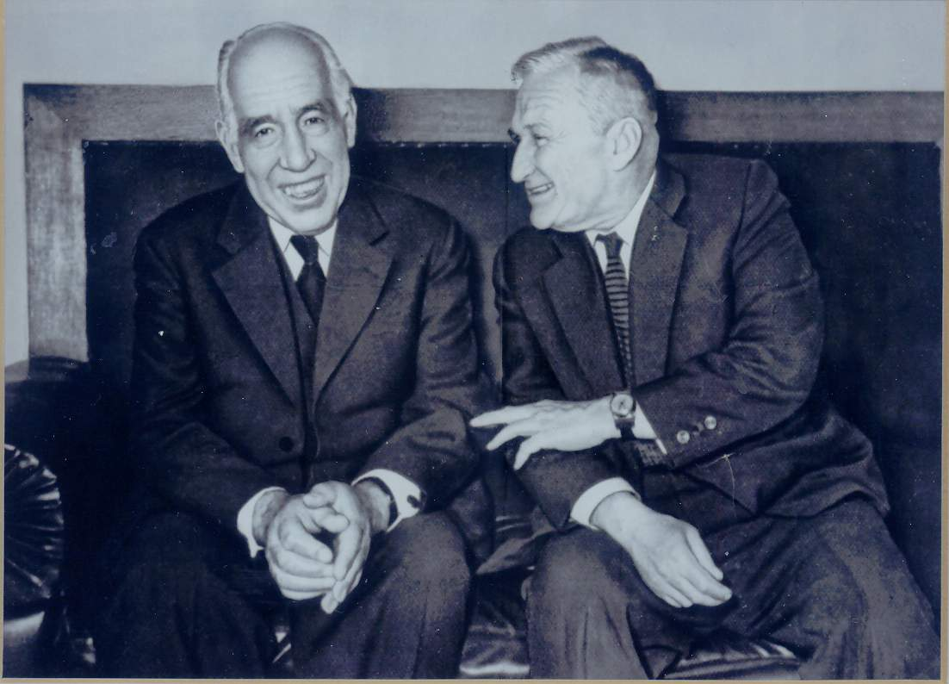
Niels Bohr and Igor Tamm, Moscow, 1961

Here are two Nobel Prize winners in Theordep of the Lebedev Institute one year before Niels Bohr’s death.

***
Then let us jump over years. There were new bombs and there were conflicts of Sakharov with the Soviet top chiefs. And to the end of 1960-th it became clear that nuclear confrontation of the nuclear super-powers threatens the very existence of the human civilization. Recently declassified cases of failure of early warning systems for a missile attack in the USA and in the USSR, when the worst did not happen by pure chance, show that humanity was really hanging by a thread. And in 1968 Sakharov writes his famous paper “Reflections on Piece, Progress and Intellectual Freedom” that was published in the West in almost 20 million circulation in two years, and that was attentively read by Soviet leaders, as declassified documents confirm.

The main idea of Sakharov’s “Reflections”: Humanity found itself on the edge of an abyss and the only way to take a step from this edge is to overcome the confrontation of the socialist and the capitalist systems. And the Soviet Government heard Sakharov – this is one more miracle in the chain of his miracles. The politics of Détente was declared by Leonid Brezhnev with its apogee – Helsinki Act from the August 1, 1975. With its famous “Third Basket” of obligations in observation of human rights.

However, all it was just “Words, words, words” (Prince Humlet). Real Soviet politics was just opposite, and Sakharov understood well that Brezhnev was incapable to stop, or even to brake somehow the giant Soviet military-industrial flywheel, or to overcome the Communist Party conservators. To overcome the enormous forces the enormous pressure was needed – the concentration of giant efforts on a smallest spot, that is at saving of the one concrete personality – political victim of regime.

The idea of the intimate connection of the observation of human rights and of the international security is absolutely untrivial. It was reflected in the title of Sakharov’s Nobel Lecture “Piece, Progress and Human Rights”, where he named 127 (one hundred and twenty seven!) names of Soviet political prisoners and apologized before those ones who he was incapable to name.

But why? How would saving one prisoner of conscience guarantee the saving of mankind? The physical analogy is a hologram when a small fragment of a system contains information about the whole system. When the judges in ancient Israel were hearing cases of murder they said addressing to witnesses: “He who saves a person saves the Whole World. Whoever kills a person kills the Whole World" (“H'ameabed nefesh ahat meabed Olam Male. H'amazil nefesh ahat mazil Olam Male”, Mishnah, “Sanhedrin”, 37a); they meant that all people came from Adam, hence killing somebody is an attack on the very principle of life.

But who followed this and when? However, beginning from the mid-1970th this approach really worked. This was the history achievement of the Soviet human rights movement, beginning from Sakharov. And this global attention to the suffering of the concrete person is perhaps the main Sakharov’s public and moral legacy.

***
Now in short about his scientific legacy. Fundamental physics has been an object of admiration for Andrei Dmitrievich throughout his life. “I felt like a messenger of the Gods,” - Sakharov said about his first report on quantum field theory at the FIAN Theoretical Physics Department in 1945.

In the words of Sakharov himself, his work on fundamental physics was carried out “on the sidelines” of the defense projects and public tasks that occupied his entire time. However, some of his works started scientific directions that are relevant today, 50-70 years after they were fulfilled. I mean the Sakharov’s approach of the magnetic confinement of hot plasma, developed in cooperation with Igor Tamm. Those are also dynamical explanation of the baryon asymmetry of the Universe (BAU), “Sakharov baryonic oscillations”, induced gravity.

Now, to Sakharov’s centenary we here in Theordep compiled the re-edition of his scientific works with the new commentaries of the top world experts. [3]

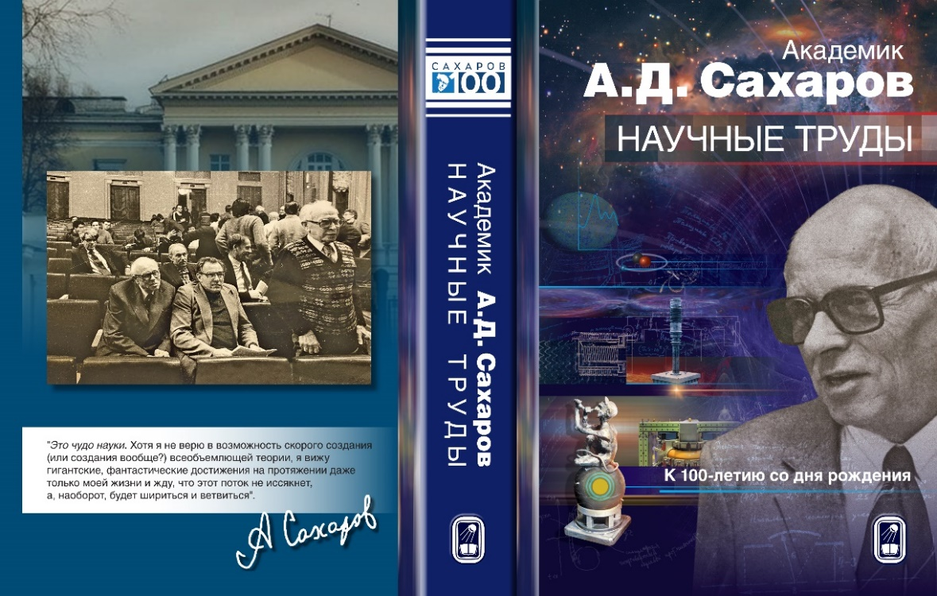

This is in a sense the continuation of the two similar previous collections:
- Academician Andrei Sakharov, “Collected Scientific Works” / Marcel Dekker Inc., New York & Basel, compiled in 1981 to Sakharov’s 60 years by Dmitry and Grigory Chudnovsky and Dirk ter Haar;
- And one compiled in Theordep of FIAN in 1995.

Also my article “Sakharov’s scientific works in modern perspective” has been published in the May 2021 issue of Uspekhi Fizicheskih Nauk.

I shall not come into details now. The only thing I want to emphasize is the paradoxical experimental confirmation of the instability of proton which is the main ingredient of the Sakharov’s explanation of the baryon asymmetry of the Universe. This experimental confirmation was proposed by Yakov Zeldovich many years ago and is reminded now by Andrei Linde in his commentaries in the re-edition of Sakharov’s scientific works [3].

Andrei Linde: “In one of his speeches, Ya.B. Zel’dovich asked the audience a question about whether there is now any experimental evidence of violation of the law of conservation of baryon charge? The naive answer is negative: the search for proton decay has not yielded any results. But Zel’dovich gave a different answer, which I give in a slightly modified form, emphasizing its paradoxicality: the fact that parallel lines do not intersect serves as experimental evidence in favor of non-conservation of the baryon charge."

I'll explain. Parallel lines do not intersect in the flat model of the Universe, which unambiguously follows from the theory of initial inflation. But this inflation also inevitably evens out any inhomogeneities and asymmetries. In the theory of inflation, the observable Universe arose from a strictly charge-symmetric initial vacuum state. This means that the baryon asymmetry of our Universe could arise only dynamically - "according to Sakharov."

However, until now it has not been possible to propose a convincing theoretical scenario in which all three classical Sakharov’s conditions of the dynamical production of BAU would be fulfilled. Moreover, today we can say with confidence that such a scenario is impossible within the framework of the Standard Model of elementary particles. Theorists are considering different versions of the Standard Model generalization, which make it possible to explain the baryon asymmetry of the Universe.

***
Let me now to share some pieces by Boris Michailovich Bolotovsky who worked in Theordep for 70 years and who unfortunately passed away two days ago, on the May 28. This is from his remembering on the visit to Sakharov in exile on November 12, 1984, soon after Sakharov’s 4-month stay in hospital because of his hunger-strike (from “Facets of a Life” [2]). There were two of them: Boris Bolotovsky and Efim Fradkin. They arrived by the train very early and in order not to wake up the hosts decided to walk around the city of Gorky.

Boris Bolotovsky:
“We wondered around the neighborhood, entering food stores. What we saw there did not make us happy. There was no cheese, no butter, no meet. I remembered the joke I heard before the trip: “Information from Gorky. Academician Sakharov stopped his hunger-strike. The rest of population of Gorky continues to starve”. ”
Sakharov was very much interested in Fradkin’s works on the string theory. On November 12 they discussed it for hours.

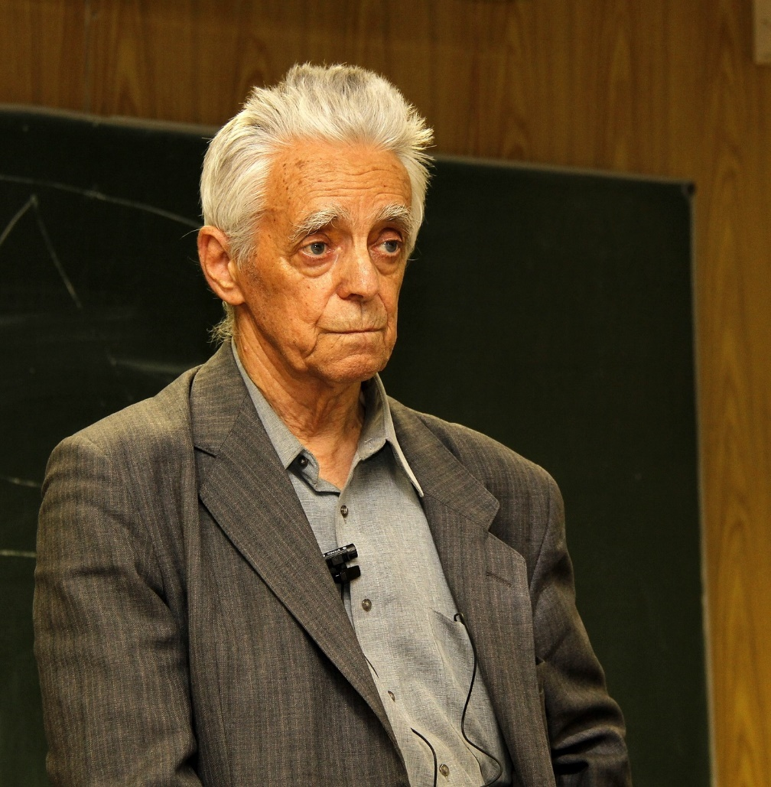

Boris Bolotovsky (1928 - 2021)

Bolotovsky:
“Then Efim started talking about his own works. And again Andrei Dmitrievich was not a passive listener. He bombarded Efim with questions and was not satisfied with the answers. More than once Efim tried to explain by writing out formulas, thinking formulas would be more convincing than words. But each time Sakharov said: “Wait a minute, Fima!”, and asked more and more questions. At last Efim begged for mercy. “Andrei Dmitrievich, let me write the formula, everything will be clear then”, - he said. “No, Fima, - Andrei Dmitrievich objected, - tell me about the problems once again. May be after that I won’t look at your formulas”.

At last Andrei Dmitrievich and Efim came to a verbal agreement, and Efim began writing out formulas – just a few lines, because everything was clear to Andrei Dmitrievich without formulas. Efim was writing and talking and Andrei Dmitrievich was listening to him in silence.”

Boris Bolotovsky also writes how depressing and hopeless it was when they left to the train in the evening leaving Sakharov in his dreadful isolation in Gorky.

In conclusion some statements about Sakharov and by Sakharov himself.

Edward Teller (“Facets of a Life” [2] p. 636):
“My brief personal contact with Sakharov convinced me of something I had earlier suspected: Sakharov was an optimist. I also consider myself an optimist. I consider optimism a necessary virtue. A pessimist is a person who is always right but gets no enjoyment from it. An optimist is a person who believes that the future is uncertain and does his best to bring about an improvement.”

John Archibald Wheeler (in “Facets of a Life” [2], p. 647, and in “Sakharov Remembered” [4], p. 79):
“Give us a new and deeper way to understand what we thought we already understood: that was Sakharov’s great gift… Never have I met anyone so senior who communicated more strongly the aura of a humble searcher for truth, one wanting to learn about the great mysteries – learn from nature, learn from the scientific literature, learn from discussion”.

Sakharov (“Memoirs” [5], pp. 579-580):
“My statements on general issues are often tentative, meant to provoke discussions, and subject to revision. I agree with Leszek Kolakowski when he writes:

“Inconsistency is simply a secret awareness of the contradictions of this world… a permanent feeling of possible personal error, or if not that, then of the possibility that one’s antagonist is right” [Leszek Kolakowski, Toward a Marxist Humanism (Grove, 1968), p. 24,]”

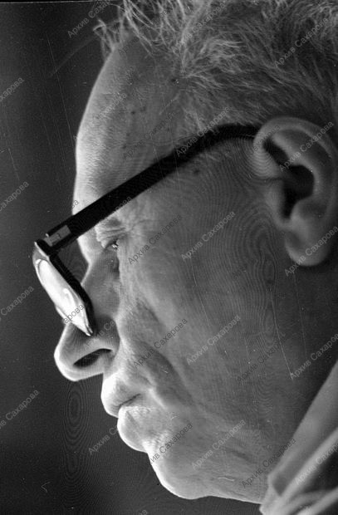
Andrei Sakharov, 16.01.1987
Photo by Yuri Rost

In the end of his second book of memoirs “Moscow and Beyond” [6] Sakharov sums up certain crucial issues of his life including science:

“This is a miracle of science. And although I do not believe in the possibility of a rapid creation (or creation at all?) of an all-encompassing theory, nevertheless I see gigantic, fantastic achievements in the course of even only my own life and expect that this flow will not dry up, but, quite the reverse, will expand and branch out…”

And I wish “fantastic achievements” to the participants of this Workshop!
See also my publication to Sakharov’s Centenary at the wen-site of the Committee of Concerned Scientists:
https://concernedscientists.org/2021/05/andrei-sakharovs-100-anniversary-boris-altshuler-human-rights-activist-and-former-ppolitical-dissident-who-worked-closely-with-sakharov-shares-his-memories-from-altshulers-artic/

References
1, Boris Altshuler, “Sakharov and the Power: ‘On the other side of the window’. Lessons for the Present and for the Future” / “Omega-L”, Moscow, May 2021. (In Russian).
2. “Andrei Sakharov. Facets of a Life. Reminiscences of colleagues” / Editorial Board: B.L. Altshuler, B.M. Bolotovsky, I.M. Dremin, V.Ya. Fainberg, L.V. Keldysh (chairman) // Editions Frontieres - P.N. Lebedev Physics Institute, Gif-sur-Yvette Cedex - France, 1991.
3. “Academician A.D. Sakharov. Scientific Works. To Sakharov’s Centenary” / Compiled by B.L. Altshuler, I.M. Dremin, V.E. Fortov (chairman), L.I. Gurvitz, V.I. Ritus, A.E. Shabad, M.A. Vasiliev // Fizmatlit, Moscow, May 2021.
4. “Sakharov Remembered. A Tribute by Friends and Colleagues ”/ Edited by S.D. Drell, S.P. Kapitza // American Institute of Physics, New York, 1991.
5. Andrei Sakharov, “Memoirs” / Translated from Russian by Richard Lourie // Alfred A. Knopf, New York, 1990.
6. Andrei Sakharov, “Moscow and Beyond” / Translated from Russian by Antonina Bouis // Alfred A. Knopf, New York, 1991.

About the author
Altshuler Boris - physicist and human rights activist.
Born on August 16, 1939 in Moscow, where he lived all his life, except for school years (1947-1956) in the nuclear center "Arzamas-16" (the town of Sarov), where his father Lev Altshuler worked together with Sakharov. Boris Altshuler himself knew Sakharov for over 20 years: 1968-1989. In 1982-1987, he was forced to work as a janitor, A.D. Sakharov, after returning from exile in December 1986, insisted on his admission to work in the Department of Theoretical Physics of the P.N. Lebedev Physics Institute of Academy of Sciences (FIAN), where B.A. is still working (2021). He participated in the compilation of a number of books about Sakharov, and wrote a lot about him. Boris Altshuler is a participant in the human rights movement in the USSR and in the Russian Federation, a member of the Moscow Helsinki Group (since 1995), Chairman of the Board of the NGO "The Right of the Child" (since 1998).

2009, Award "Person of the Year - 5769 for many years of human rights work, humanitarian actions in favor of children" by the Federation of Jewish Communities of Russia (FEOR). Presentation at the Grand Kremlin Palace -
http://right-child.ru/2009_boris_altshuler.html

2013 – Andrei Sakharov Prize of the American Physical Society "For many years of struggle in defense of democracy in Russia and for activities to protect children's rights".

2019 - Award "Parental Thank You!" by the All-Russian Organization of Parents of Disabled Children (VORDI).

